**CLASSIFICATION REPORT**

**Classification Report For 1000 sample**

|  |  |  |  |  |
| --- | --- | --- | --- | --- |
|  | Precision | Recall | F1-score | Support |
| 0 | 0.76 | 0.80 | 0.78 | 139 |
| 1 | 0.48 | 0.43 | 0.45 | 61 |
| Accuracy |  |  | 0.69 | 200 |
| Macro avg | 0.62 | 0.61 | 0.62 | 200 |
| Weighted avg | 0.68 | 0.69 | 0.68 | 200 |

**Classification Report For 2000 sample**

|  |  |  |  |  |
| --- | --- | --- | --- | --- |
|  | Precision | Recall | F1-score | Support |
| 0 | 0.78 | 0.70 | 0.74 | 294 |
| 1 | 0.35 | 0.44 | 0.39 | 106 |
| Accuracy |  |  | 0.63 | 400 |
| Macro avg | 0.56 | 0.57 | 0.56 | 400 |
| Weighted avg | 0.66 | 0.63 | 0.65 | 400 |

**Classification Report For 500 sample**

|  |  |  |  |  |
| --- | --- | --- | --- | --- |
|  | Precision | Recall | F1-score | Support |
| 0 | 0.77 | 0.78 | 0.78 | 74 |
| 1 | 0.36 | 0.35 | 0.35 | 26 |
| Accuracy |  |  | 0.67 | 100 |
| Macro avg | 0.57 | 0.56 | 0.57 | 100 |
| Weighted avg | 0.67 | 0.67 | 0.67 | 100 |
|  |  |  |  |  |
|  |  |  |  |  |

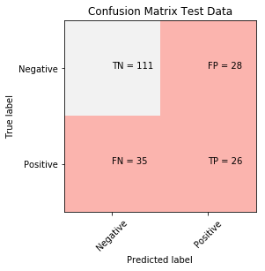

**10 samples that Insult is equal to 1 and succesful**

1. you are soooo inteligent white girl Tell us black people more about ourselves Im sure u know more about us then we do
2. this post is so shallow and pathetic Kudos to people who are growing old with out trying to defy the laws of nature and half of your posts are merely bad pictures you are trying to write off as not growing old well Must be a slow news day because this is truly an all time low
3. Well you just lost all credibility when you said you were a student of Limbaugh University Now you are just a TROLL Nobody cares what you think or say you are being flagged every time you post one of your degrading comments Enjoy while it lasts
4. Well you just lost all credibility when you said you were a student of Limbaugh University Now you are just a TROLL Nobody cares what you think or say you are being flagged every time you post one of your degrading comments Enjoy while it lasts
5. Go and tell him to fuck himself the twat
6. Oh bore off you Stupid twat
7. Yeah you probably havew a dick to you ugly fucking monkey black whore you are not even a women to me no black women are I think of you as monkeys that should be in the zoo Now go get your cunt sterilized slus so you dont make any more nixxers
8. You are a fool
9. coming on here to hate get a fucking life this is straight fire you dont like it your a pussy
10. What an ass you arefunny I see a lot more of you nuts in cars then I ever have of pilots in panes

**10 samples that Insult is equal to 1 and unsuccesful**

1. disqus nnYouve got islamic apologist written all over your face These people were poisoned plain and simple
2. No people like you are the problem we are having in this World
3. You are a lying son of a bitch s see you post some facts supporting your assertion
4. No you f u c k head
5. just go away because you get dumber by the day You probably even foegt where the subject began dumb dumb
6. What a smug basket you are
7. Because you are an idiot jpcali
8. You a fucking little coward of a bitch
9. This website should have been named wwwhaterscentralcom because this website is full of people like you
10. truthfully your logic with the and the political statement just made everyone a little bit more dumb on this article comment section In fact you are probably in the and the bullshit irrelevant statistical fact you made up group Put the remote down and read a book retard

**10 samples that Insult is equal to 0 and succesful**

1. I get how this works You work with Congress unless it wont do what you want in which case you simply decree your will You are a child if you dont understand whats wrong with this
2. madonna is the worlds best singerr for everrrrrrrr and everrrrrrn fuck yourself you stupid ugly copy cattttt nbillboard listed madonna only after the beatles the gretest singer of all time so gaga and little monsters go fuck yourselvesss ha ha ha ha youre copy cat will never reach any thing like this ha ha ha ha
3. Whaaaaaat Excuse me while I puke
4. Holy shit is droppin science
5. Yes so u are wrong
6. you troll so hard
7. Of course Aybbar is the one that gets the outnHe sucks
8. gotta keep on them about that stuff
9. Yo this shits raw reminds me of the Number Playaz Their song Haters goes hard now that a crew I can fuck with Check out their song and fuck the haters
10. This place will become another millenium dome spurs are not a big enough club for this sort of stadium Its got failure as a football stadium and thus becomes a concert arena to pay the bills written all over it and the funny thing is who the hell will travel to Tottenham for a concert There will be a big white elephant in tottenham to replace the rusty chicken hahahahahahann nn

**10 samples that Insult is equal to 0 and unsuccesful**

1. fucking russians
2. clintons shirt should read way to go Barry i screwed a intern you screwed the whole country
3. Cars was like fuck this im outta here
4. Its built like a brick shithouse
5. What a t u p d p h u c k k i n g k u u n n t t
6. You are so confused
7. Bailey is built for sex So hot
8. fuCk i love this brand gibson
9. Fuck the kid lets get the narrator from bastion Also he narrates the movie
10. i fucking love peanuts

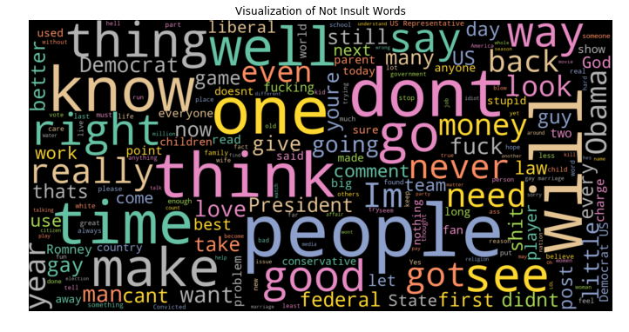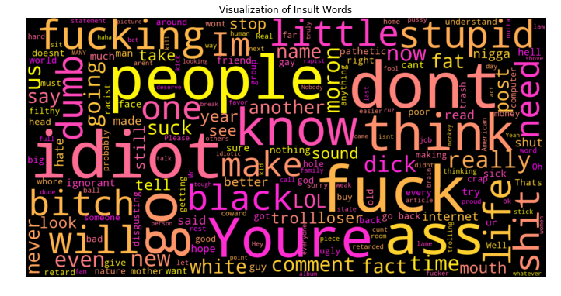

EZGİ ATEŞ - 19501047